
Staff Profile Form

Personal Information
Surname |  | First Name |  | Middle Name |  |  | Maiden/Other Names used  (if applicable)
ADEWOPO |  | OLUWAGBOHUNMI |  | AYOADE
Date of Birth (DD/MM/YY) |  |  | Nationality |  | NIN & BVN |  | State of Origin
24/04/2001 |  |  | NIGERIAN |  | NIN: 76523615150  BVN: 22453350644 |  | OSUN STATE
Title (please circle)  Mr. Mrs Miss Other |  |  | Gender MALE |  | Religion CHRISTAIN |  | Tel. No 07025316400
Marital Status | Date of Marriage |  |  | Name of Spouse |  |  | Spouse’s Profession
SINGLE | NOT APPLICABLE |  |  | NOT APPLICABLE |  |  | NOT APPLICABLE
Residential Address
NO 4, MARI-CUTE STREET, TORIKOH, BADAGRY, LAGOS
Postal Address
NO 4, MARI-CUTE STREET, TORIKOH, BADAGRY, LAGOS
Private Email Address oluwagbohunmidewopo@gmail.com
Name/Address of Next of Kin |  |  |  |  |  | Relationship | Tel No.
ADEWOPO ADENIYI  LIGHT HOUSE, AKARAPA, IGBOROSUN, BADAGRY LAGOS |  |  |  |  |  | FATHER | 08026273342

Family Details
NAME (Spouse and Children) | Date of Birth | Relationship

Do you have any criminal convictions in any country? | Yes |  | No | ✔
If yes, please give details:
Emergency Contact
Name: ADEWOPO ADEMBIPO OSEYEMI
Relationship: MOTHER
Address: NO 4 MARI-CUTE STREET, TORIKOH BADAGRY LAGOS

Telephone: 08039878884

Educational/Professional Details
Please list educational qualifications beginning with the most recent.
Professional/Other Qualifications | Institution/Location | Dates:  From To |  | Degree/Certificate/Qualifying grade (Attach copies)
College/University/ Polytechnic | Institution/Location | Dates:  From To |  | Degree/Certificate/Qualifying grade (Attach copies)
AFE BABALOLA UNIVERSITY, ADO-EKITI | ADO-EKITI | 2017 | 2022 | 
Secondary/ Technical School | Institution/Location | Dates:  From To |  | Degree/Certificate/Qualifying grade (Attach copies)
DEEPER LIFE HIGH SCHOOL | DEEPER LIFE CONFRENCE CENTER, KM 42 LAGOS IBADAN EXPRESSWAY, MOWE | 2011 | 2017 | 

Language Proficiency (Tick appropriate columns)
Language | Speaking |  |  | Writing |  |  | Reading
 | Low | Med | High | Low | Med | High | Low | Med | High
English Language |  |  | ✔ |  |  | ✔ |  |  | ✔
Nigerian Pidgin |  | ✔ |  | ✔ |  |  | ✔

Previous Employment Details
List your last three employment details, starting from the most recently held position
Date Employed (mm/yy)  9TH SEPTEMBER, 2025 | Organization Name/ Address:  TEMARUCO CLOTHING COMPANY, AJAH LAGOS
Job Title: | PROCUREMENT OFFICER
Reason for leaving
I WANTED TO FOCUS ON MY CAREER

Date Employed (mm/yy)  From: 28TH SEPTEMBER 2024 To: 5TH AUGUST 2025 |  | Organization Name/ Address:  NIGERIAN AIRFORCE, 053 NAF CAMP  MOGADISHU BARRACKS ASOKORO, ABUJA
Job Title: NYSC CORPER | Responsibilities:  1. I worked as an automobile engineer for the Nigerian Airforce at 053 NAF Camp.  2. I was given the responsibility of the maintenance the Nigerian Airforce Vehicles.  3. I was involved with tasks such as servicing of automobile, breaks, changing of lower camber, changing of brake calipers and other automobile services.  4. I also helped in quality assurance of replacement parts for vehicles.  5. I also had the responsibility of inspecting new vehicles bought by the Nigerian Airforce to ensure they are of good quality before being used.
Reason for leaving:
I WAS DONE WITH MY NYSC

Date Employed (mm/yy)  From: 1ST DECEMBER, 2023 To: 12TH JUNE, 2024 | Organization Name/ Address:  SWITCH LOUNGE, ADMIRALTY WAY LEKKI, LAGOS.
Job Title: STORE KEEPER/ PROCUREMENT OFFICER | Responsibilities:  1. I worked as a store keeper at Switch lounge in Lekki, Lagos state.  2. I took on the responsibility of organizing, taking records and procurements of stocks at the  organization.  3. I was also responsible for the organization of debts for our suppliers.
Reason for leaving
I LEFT FOR MY NYSC

No. of work experience (years, months): | 1 YRS, 9 MONTHS

Skills and Proficiencies:
Skills/Proficiencies possessed | Level of Expertise (Please tick)
 | Basic | Medium | Advanced
Computer Skills |  |  | ✔
Communication Skills |  |  | ✔

References (please do not include relatives)
Personal Referee
Name | Surname |  | Other Names
ABDULHAFEEZ | ALHASSAN
Address: MALALE ROAD, KADUNA, NIGERIA.
Email: abdulhafeez142@gmail.com
Occupation: Engineer |  | Job Title: Mechanical Engineer
Phone No: 08062943355
Religion: Muslim
Address of Church/Mosque/Other: Kaduna Central Mosque

Professional Referee 1
Name | Surname |  | Other Names
GREGORY | UMUSU
Address: BLOCK C2, NAF BASE, AIRPORT ROAD, ABUJA NIGERIA
Email: gregoryumusu@gmail.com
Occupation: NIGERIAN AIRFORCE OFFICER |  | Job Title: SUPERVISOR/ PILOT
Company: NIGERIAN AIRFORCE
Religion: CHRISTAIN
Address of Church/Mosque/Other: NAF CATHOLIC CHURCH, AIPORT ROAD, ABUJA NIGERIA

Professional Referee 2 (Fresh Graduates to provide Academic Referees)
Name | Surname |  | Other Names
ESME | JAJA
Address: REEDEMERS CLOSE LEKKI NIGERIA
Email:
Occupation: MD |  | Job Title: MD
Company: SWITCH LOUNGE
Phone No: 08033139028
PFA and Tax Details (For new hires already working in Nigeria)
Who is your PFA?:
NIL
What is your RSA Number?
NIL
What is your Tax ID?
NIL
(If you did not have a PFA or NHF, please contact HR immediately for information on the Pension Reform Act 2004 and National Housing Fund Scheme)
State your bank details for salary
ACCOUNT NUMBER: 1892725022
ACCOUNT BANK: ACCESS BANK
ACCOUNT NAME: ADEWOPO OLUWAGBOHUNMI AYOADE
____________ _____________________________________________________________________________

Declaration

I hereby declare that all the information in this form is complete, factually correct, and honestly presented.
Name ADEWOPO OLUWAGBOHUNMI AYOADE
Signature: 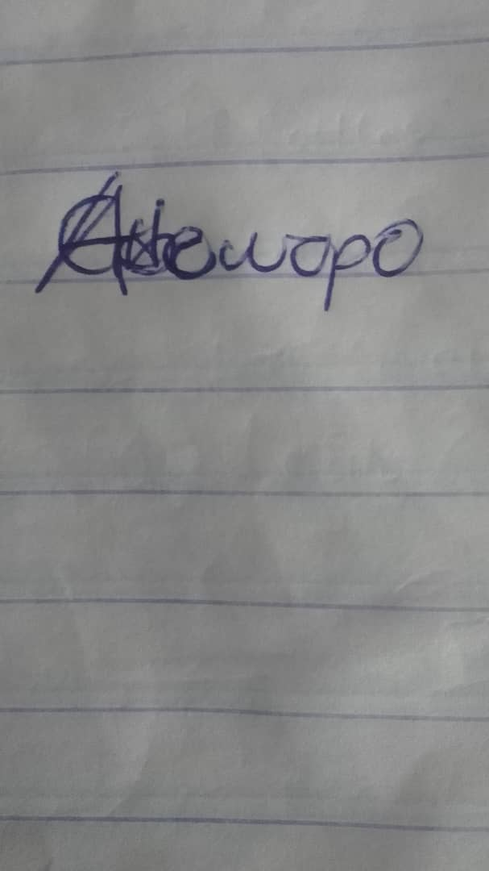
Date: Wednesday, February 11, 2026

